VIRGINIA BEACH FIRE DEPT.

ovfd8.org

VOLUNTEER
SUPPORT TECHNICIAN
TRAINING SYLLABUS

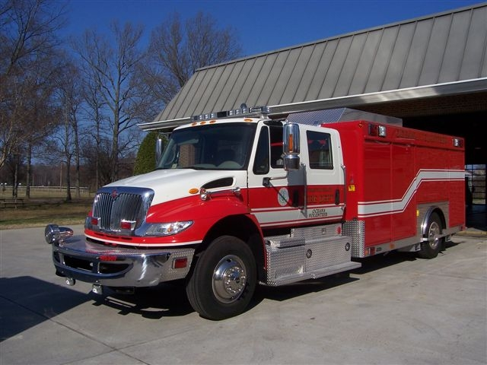

DUTY SUPPORT CREW MEMBER

DUTY SUPPORT CREW LEADER

DUTY VOLUNTEER VEHICLE DRIVER

BRUSH / UTV CERTIFIED OPERATOR

NAME: _________________________

FDID #: _______________________ JUL 2019
Individuals undergoing training as Duty Support Crew Members, Duty Support Crew Leaders, Duty Volunteer Vehicle Drivers, and Brush / UTV Certified Operators must be able to Verbalize and Demonstrate their abilities to perform all tasks indicated. Support trainees are required to receive 3 sets of FDID #’s (Last 3 numbers) from different Duty Support Crew Leaders (as much as possible) qualified to check-off tasks accomplished. Qualified individuals are those members who have received “check-off” numbers in all three (3) performance categories (Knowledge, Competency, and Proficiency) for any single line item. Numbers must be legible, and the VST Crew Leader known for a “check-off” to be allowed. It may become necessary for Trainees to come into the station at times other than scheduled to ensure different qualified individual numbers are received within the time frame specified.

Trainees being certified in all areas must receive the signature of a member of the “Battalion 30 Training Staff” and conduct a short interview with Battalion 30. Trainees being certified as “Duty Volunteer Vehicle Drivers” must also perform a Battalion 30 Ride-along before receiving a certification signature from Battalion 30.

For all positions, exhibiting the 3 categories of performance (Knowledge, Competency, and Proficiency) is paramount prior to receiving any set of numbers. Simply going through the motions of “doing” a task on a one-time basis will not necessarily result in receiving an item being checked-off. Any questions may be directed to me for clarification.

Item Check-Off may be acknowledged, however completion of the VBFD approved VST Recruit Academy is required prior to certification at any level of training.

Wayne
W. F. Richardson
Fire Chief, OVFD
Vol. Battalion Chief, VBFD
JUL 2019
VOLUNTEER SUPPORT TECHNICIAN CERTIFICATION PROCEDURES

A. SUPPORT TECHNICIAN - CERTIFIED DUTY SUPPORT CREW MEMBER (SUPPORT)

KNOWLEDGE COMPETENCY PROFICIENCY .

1. Perform Check-off of Support 8, Brush 8, and UTV 8 utilizing the current Duty Crew Equipment
Check-off Sheets, noting the procedure to be followed when discrepancies are noted.

Date: FDID: Date: FDID: Date: FDID: .

2. Locate, Identify, and Demonstrate the use of the provided hand tools (manual and power),
“overhaul” equipment, light towers & portable lights on Support 8, Brush 8, and UTV 8.

Date: FDID: Date: FDID: Date: FDID: .

3. Verbalize and Demonstrate the mechanics, and the procedure for Documenting, Handling, and
Refilling SCBA air cylinders utilizing the Support 8 cascade and air compressor systems.

Date: FDID: Date: FDID: Date: FDID: .

4. Locate, Identify, & Operate Support 8 rehab equipment and Verbalize on-scene rehab procedures.

Date: FDID: Date: FDID: Date: FDID: .
_________________________________________________________________________________________________

B. SUPPORT TECHNICIAN - CERTIFIED DUTY SUPPORT CREW LEADER (SUPPORT)

1. Verbalize and Demonstrate the ability to Log onto, Operate ALL current programs, Interpret, and
Log-off of the City provided “Mobile Data Terminal” (MDT) (Must have valid system passwords!).

Date: FDID: Date: FDID: Date: FDID: .

2. Successfully complete the “Support Crew Proficiency Exam” and Duty Crew Leader interview administered by Battalion 30, and served at least Six (6) months as an active Vol. Vehicle Driver.

Test: B-30: Interview: B-30: 6 mos.: FDID: .

3. Participate in 3 “working” emergency scene incidents (Over a period of at least 1 month), then Verbalize & Demonstrate the ability to manage a crew and interface with ICS on-scene personnel.

Date: FDID: Date: FDID: Date: FDID: .

4. Participate in 1 “working” emergency scene “scenario” practical test, Verbalizing & Demonstrating the ability to manage a crew and interface with ICS on-scene personnel.

Member: B-30 Training: Leader - Test: B-30: .

Department Seal
VOLUNTEER SUPPORT TECHNICIAN CERTIFICATION PROCEDURES

C. SUPPORT TECHNICIAN - CERTIFIED VOLUNTEER VEHICLE DRIVER (SUPPORT / BRUSH)

KNOWLEDGE COMPETENCY PROFICIENCY .

1. Verbalize the responsibilities of the Duty Driver with regards to his/her duty crew members, both
in-station and on any given emergency or non-emergency scene (Understand Support procedures)

Date: FDID: Date: FDID: Date: FDID: .

2. Verbalize and Demonstrate the procedures for checking-off the engine compartment and vehicle
mechanics (electrical and mechanical) of Support 8, Brush 8, & UTV 8, noting the procedure to be
followed when discrepancies are noted.

Date: FDID: Date: FDID: Date: FDID: .

3. Verbalize and Demonstrate the ability to operate and interpret the support vehicle’s “Systems
Monitoring” computer, noting the procedure to be followed when discrepancies are noted.

Date: FDID: Date: FDID: Date: FDID: .

4. Verbalize and Demonstrate the procedures to be followed with regards to communications,
response procedures, and associated policies when responding to the scene of any given incident
(assist citizen, “bottle fill” request, working fire, etc.) if performing as both Driver and Crew Leader.

Date: FDID: Date: FDID: Date: FDID: .

5. Demonstrate the ability to Drive, Park, and Back the Support and Brush vehicles as directed,
following all applicable safety procedures and VBFD Standard Operating Procedures (SOP’s).

Date: FDID: Date: FDID: Date: FDID: .

6. Demonstrate the ability to Place Into, and Operate Brush 8 in “off road” conditions (4-Wheel Drive)

Date: FDID: Date: FDID: Date: FDID: .

7. Have Passed Va. State certified Emergency Vehicle Operator Course (EVOC) w/certificate on file,
received the recommendation of the Battalion 30 Training Staff, Performed a B-30 ride-along, and
been certified by Battalion 30 as a “Volunteer Vehicle Driver.”

EVOC Date: FDID: . Completion Date: FDID: .

NAME: _ ___________________ DATE STARTED: ____________________

FDID #: ____________________ DATE CERTIFIED: ____________________

Department Seal (B30 TRAINING) ________________________ (B30) ____________________________ JUL 2019
VOLUNTEER SUPPORT TECHNICIAN - BRUSH / UTV OPERATIONS TRAINING

PURPOSE: Train Volunteer Support Technician – (VST) personnel to allow qualified personnel to operate and fight brush fires from Brush 8 independent of supervision.

TRAINING STARTED: __________________ CERTIFIED: ___________________

PRE-QUALIFICATIONS: The following must be certified prior operating Brush/UTV 8:

- Must be “Driver” certified as specified in “VBFD VST Training Syllabus”
- Must have completed VST “Wildland Firefighting” Training program
3. Must receive documented approval from VBFD Volunteer Battalion Chief
4. Must have Passed the Full VBFD Firefighter Physical & Fitness Test

OVERVIEW: VST “Brush 8/ UTV 8 Certified Operators” must be able to:

- Operate (Drive) Brush 8 / UTV 8 during off road conditions
- Operate all aspects of pumping Brush 8 / UTV 8
- Operate and put into service the floating pump
- Demonstrate a basic understanding of how to combat brush/wildland fires.
- Demonstrate Competency in all Training items certified by FDID last 3 numbers.

TRAINING OUTLINE:

- Operate Brush 8 / UTV 8 in off road conditions FDID Date

- When to use 4-wheel drive, and the difference
between 4L and 4H _______ _________
- When to “air down” tires and by how much _______ _________
- Identify Roll Over possibilities _______ _________
- How to avoid / handle getting stuck when off-road _______ _________
- Demonstrate winch usage _______ _________
- Allowing for an exit strategy _______ _________

- Operate all aspects of pumping Brush 8 / UTV 8

- Basic Brush 8 / UTV 8pump operations _______ _________
- Charging pre-connected and booster hose lines _______ _________
- Pumping pressures for hose, distance, and nozzle _______ _________
- Filling from hydrant, tanker, or drafting source _______ _________
- Hose usage and combinations _______ _________

Page 1 JUN 2019
- Operate and put into service the floating pump FDID Date

- Safety precautions, starting ops, and maintenance _______ _________
- Hose combinations and hardware usage _______ _________
- Used as a water source for Brush 8 or attack lines _______ _________
- ID areas supporting deployment of the floating pump _______ _________

- Demonstrate a basic understanding of brush/wildland firefighting procedures

- Safety aspects and scene assessment of conditions _______ _________
- Knowing limitations of personnel and equipment _______ _________
- Recognizing in-place attack plans being utilized _______ _________
- Exit strategy _______ _________
- Water management _______ _________
- Tool usage _______ _________

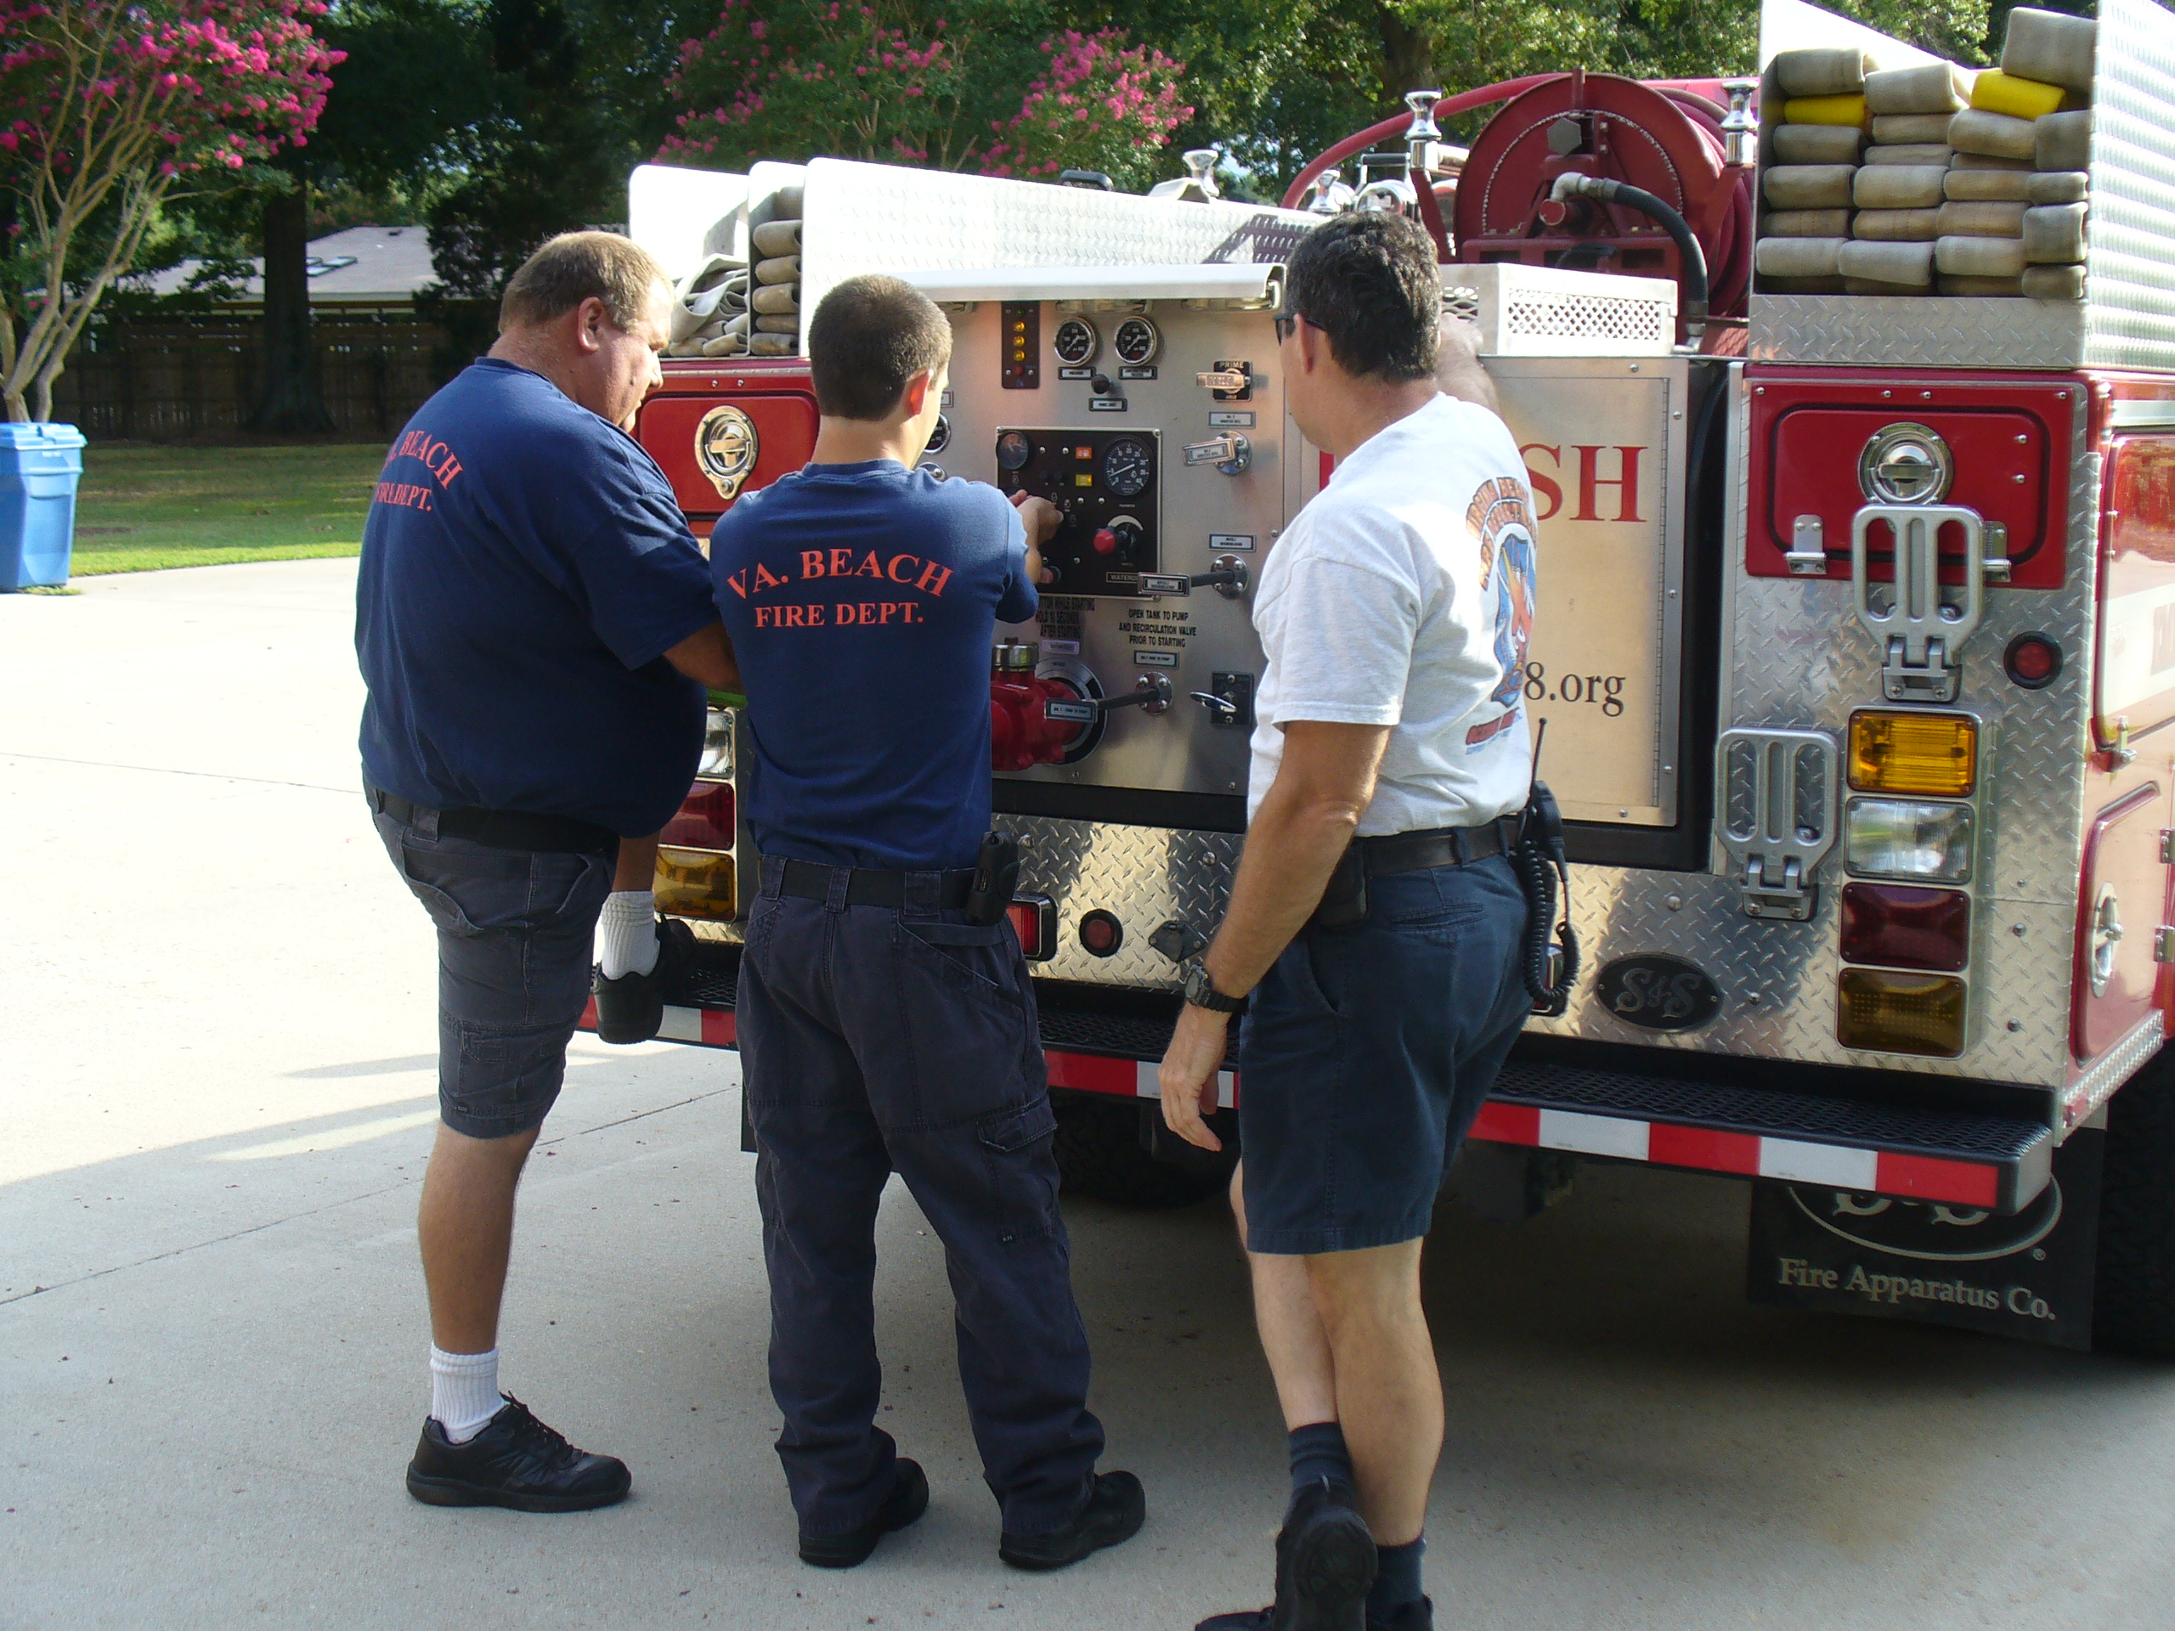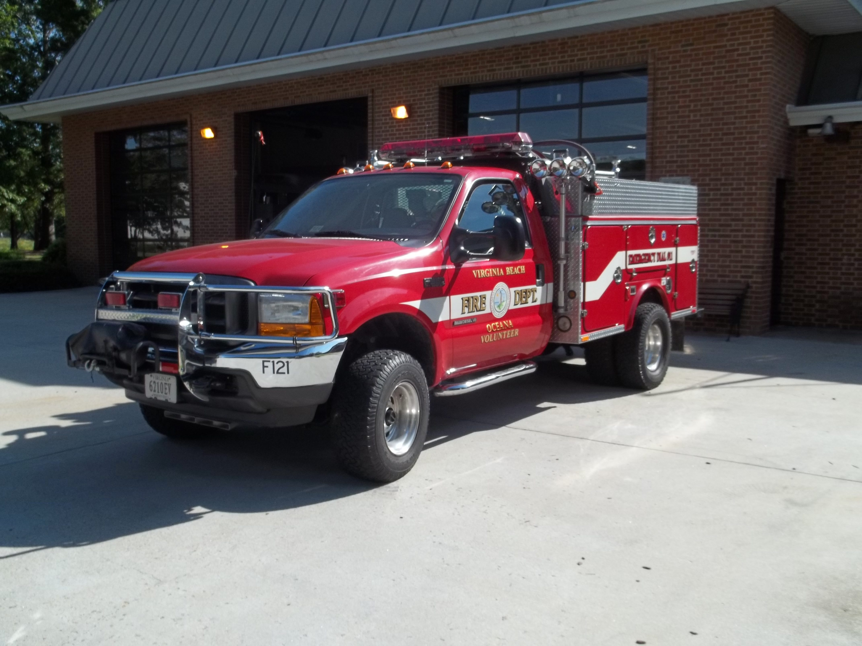

NAME: _____________________________________ FDID: ________________

CERTIFIED BY: _________________________________ DATE: ____________
B-30 APPROVAL:

_______________________________________ ________________
W. F. Richardson, Volunteer Battalion Chief DATE

Department Seal Page 2 JUL 2019
VIRGINIA BEACH FIRE DEPT.
VOLUNTEER SUPPORT TECH.
PRE-CREW MEMBER
RECRUIT CERTIFICATIONS

Volunteer Support Technician Recruits are required to complete the following On-Line courses and submit proof of completion prior to being assigned as “Crew Members” on VBFD Volunteer apparatus: Go to the following link and complete the listed courses. Print and deliver your certificates to Battalion 30, or e-mail to wrichard@vbgov.com

https://www.vbems.com/training/initial-online-training-for-new-members/
- FEMA National Incident Management System (NIMS) ICS 100, 200, 700, and 800
__________________ _____________
Date Initials
- Blood Borne Pathogens / OSHA Update
__________________ _____________
Date Initials

- WMD/Terrorism Awareness for Emergency Responders
_________________ _____________
Date Initials

- CPR CERTIFICATION (if you have a current CPR card, submit a copy. If no CPR card we will make an effort get you into the next available CPR class or let you know where one may be completed as soon as possible.
__________________ ____________
Date Initials

STATION LOCATION QUIZ (On Reverse)

NAME: ___________________________________ DATE: _________________

FDID: _________________________

FS. # FIRE STATION NAME ADDRESS / GENERAL LOCATION

1 ___________________ ________________________________________

2 ___________________ ________________________________________

3 ___________________ ________________________________________

4 ___________________ ________________________________________

5 ___________________ ________________________________________

6 ___________________ ________________________________________

7 ___________________ ________________________________________

8 ___________________ ________________________________________

9 ___________________ ________________________________________

10 ___________________ ________________________________________

11 ___________________ ________________________________________

12 ___________________ ________________________________________

13 ___________________ ________________________________________

16 ___________________ ________________________________________

17 ___________________ ________________________________________

18 ___________________ ________________________________________

19 ___________________ ________________________________________

20 ___________________ ________________________________________

21 ___________________ ________________________________________

