VIRGINIA BEACH FIRE DEPARTMENT
OCEANA VOLUNTEER FIRE DEPARTMENT, Inc.

PROSPECTIVE APPLICANT MESSAGE

- Applicants interested in joining the Virginia Beach Fire Department as a Volunteer Support Technician (VST) are directed to the Volunteer Resources page On-Line application listed under Fire:

https://volunteer.virginiabeach.gov/volunteer-opportunities
Click on: View Descriptions > Fire > Support Technicians > Apply Here
After completing the form, sign using your e-signature and click "Submit" at the bottom of the page.
- Once there, fill out the application and submit the required documents (copy of Driver’s License and DMV Driving Record).

- Once completed, the volunteer office will be able to run the applicant’s Social Services Background Check.

- Once that is completed, VBFD Human Resources (HR) will review the information to make sure everything is correct.

- If so, VBFD HR will send the applicant information to get a Physical Evaluation performed.

- Once receiving the all clear from Occ Health, applicants will be given instructions on how to begin their participation as a VST and begin their Fire Training.

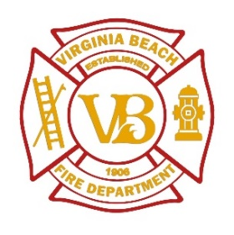
Wayne F. Richardson Ariel Johnson
Fire Chief, OVFD VB Fire Department
Vol. Battalion Chief, VBFD Recruiter
757-385-6308 (Office) 757-385-5640 (Office)
wrichard@vbgov.com fire.virginiabeach.gov

